Introduction to Model Context Protocol (MCP)
Welcome to Unit 1 of the MCP Course! In this unit, we’ll explore the fundamentals of Model Context Protocol.
What You Will Learn
In this unit, you will:
- Understand what Model Context Protocol is and why it’s important
- Learn the key concepts and terminology associated with MCP
- Explore the integration challenges that MCP solves
- Walk through the key benefits and goals of MCP
- See a simple example of MCP integration in action
By the end of this unit, you’ll have a solid understanding of the foundational concepts of MCP and be ready to dive deeper into its architecture and implementation in the next unit.
Importance of MCP
The AI ecosystem is evolving rapidly, with Large Language Models (LLMs) and other AI systems becoming increasingly capable. However, these models are often limited by their training data and lack access to real-time information or specialized tools. This limitation hinders the potential of AI systems to provide truly relevant, accurate, and helpful responses in many scenarios.
This is where Model Context Protocol (MCP) comes in. MCP enables AI models to connect with external data sources, tools, and environments, allowing for the seamless transfer of information and capabilities between AI systems and the broader digital world. This interoperability is crucial for the growth and adoption of truly useful AI applications.
Overview of Unit 1
Here’s a brief overview of what we’ll cover in this unit:
- What is Model Context Protocol? - We’ll start by defining what MCP is and discussing its role in the AI ecosystem.
- Key Concepts - We’ll explore the fundamental concepts and terminology associated with MCP.
- Integration Challenges - We’ll examine the problems that MCP aims to solve, particularly the “M×N Integration Problem.”
- Benefits and Goals - We’ll discuss the key benefits and goals of MCP, including standardization, enhanced AI capabilities, and interoperability.
- Simple Example - Finally, we’ll walk through a simple example of MCP integration to see how it works in practice.
Key Concepts and Terminology
Before diving deeper into the Model Context Protocol, it’s important to understand the key concepts and terminology that form the foundation of MCP. This section will introduce the fundamental ideas that underpin the protocol and provide a common vocabulary for discussing MCP implementations throughout the course.
MCP is often described as the “USB-C for AI applications.” Just as USB-C provides a standardized physical and logical interface for connecting various peripherals to computing devices, MCP offers a consistent protocol for linking AI models to external capabilities. This standardization benefits the entire ecosystem:
- users enjoy simpler and more consistent experiences across AI applications
- AI application developers gain easy integration with a growing ecosystem of tools and data sources
- tool and data providers need only create a single implementation that works with multiple AI applications
- the broader ecosystem benefits from increased interoperability, innovation, and reduced fragmentation
The Integration Problem
The M×N Integration Problem refers to the challenge of connecting M different AI applications to N different external tools or data sources without a standardized approach.
Without MCP (M×N Problem)
Without a protocol like MCP, developers would need to create M×N custom integrations—one for each possible pairing of an AI application with an external capability.
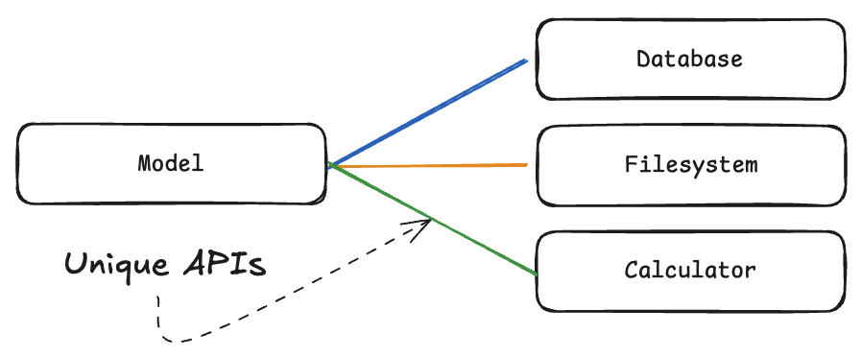
Each AI application would need to integrate with each tool/data source individually. This is a very complex and expensive process which introduces a lot of friction for developers, and high maintenance costs.
Once we have multiple models and multiple tools, the number of integrations becomes too large to manage, each with its own unique interface.
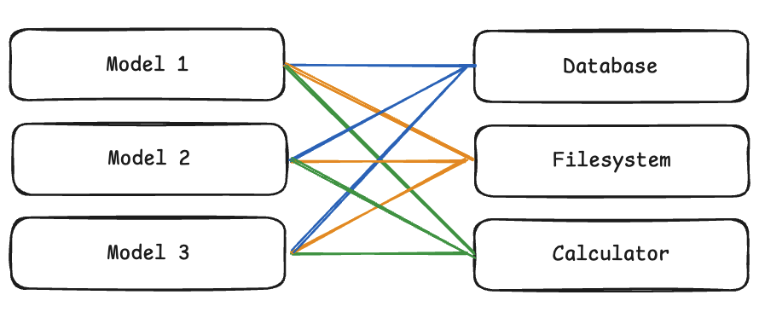
With MCP (M+N Solution)
MCP transforms this into an M+N problem by providing a standard interface: each AI application implements the client side of MCP once, and each tool/data source implements the server side once. This dramatically reduces integration complexity and maintenance burden.
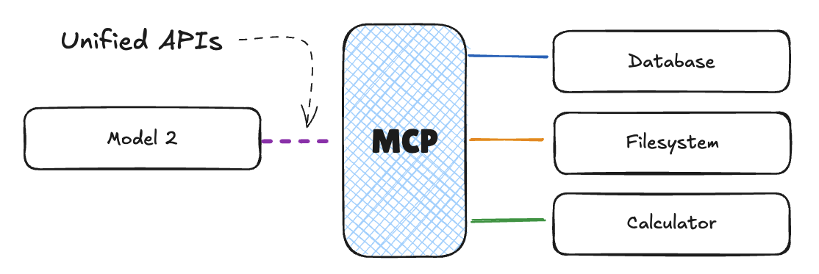
Core MCP Terminology
Now that we understand the problem that MCP solves, let’s dive into the core terminology and concepts that make up the MCP protocol.
MCP is a standard like HTTP or USB-C, and is a protocol for connecting AI applications to external tools and data sources. Therefore, using standard terminology is crucial to making the MCP work effectively.
When documenting our applications and communicating with the community, we should use the following terminology.
Components
Just like client server relationships in HTTP, MCP has a client and a server.

- Host: The user-facing AI application that end-users interact with directly. Examples include Anthropic’s Claude Desktop, AI-enhanced IDEs like Cursor, inference libraries like Hugging Face Python SDK, or custom applications built in libraries like LangChain or smolagents. Hosts initiate connections to MCP Servers and orchestrate the overall flow between user requests, LLM processing, and external tools.
- Client: A component within the host application that manages communication with a specific MCP Server. Each Client maintains a 1:1 connection with a single Server, handling the protocol-level details of MCP communication and acting as an intermediary between the Host’s logic and the external Server.
- Server: An external program or service that exposes capabilities (Tools, Resources, Prompts) via the MCP protocol.
A lot of content uses ‘Client’ and ‘Host’ interchangeably. Technically speaking, the host is the user-facing application, and the client is the component within the host application that manages communication with a specific MCP Server.
Capabilities
Of course, your application’s value is the sum of the capabilities it offers. So the capabilities are the most important part of your application. MCP’s can connect with any software service, but there are some common capabilities that are used for many AI applications.
Capability | Description | Example
Tools | Executable functions that the AI model can invoke to perform actions or retrieve computed data. Typically relating to the use case of the application. | A tool for a weather application might be a function that returns the weather in a specific location.
Resources | Read-only data sources that provide context without significant computation. | A researcher assistant might have a resource for scientific papers.
Prompts | Pre-defined templates or workflows that guide interactions between users, AI models, and the available capabilities. | A summarization prompt.
Sampling | Server-initiated requests for the Client/Host to perform LLM interactions, enabling recursive actions where the LLM can review generated content and make further decisions. | A writing application reviewing its own output and decides to refine it further.
In the following diagram, we can see the collective capabilities applied to a use case for a code agent.
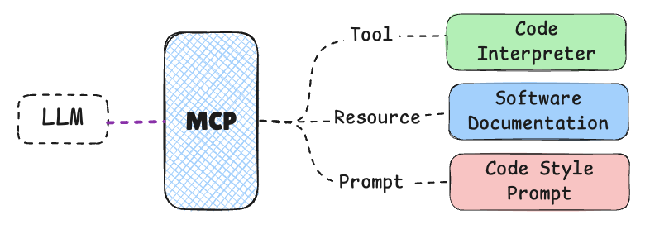
This application might use their MCP entities in the following way:
Entity | Name | Description
Tool | Code Interpreter | A tool that can execute code that the LLM writes.
Resource | Documentation | A resource that contains the documentation of the application.
Prompt | Code Style | A prompt that guides the LLM to generate code.
Sampling | Code Review | A sampling that allows the LLM to review the code and make further decisions.
Conclusion
Understanding these key concepts and terminology provides the foundation for working with MCP effectively. In the following sections, we’ll build on this foundation to explore the architectural components, communication protocol, and capabilities that make up the Model Context Protocol.
Architectural Components of MCP
In the previous section, we discussed the key concepts and terminology of MCP. Now, let’s dive deeper into the architectural components that make up the MCP ecosystem.
Host, Client, and Server
The Model Context Protocol (MCP) is built on a client-server architecture that enables structured communication between AI models and external systems.
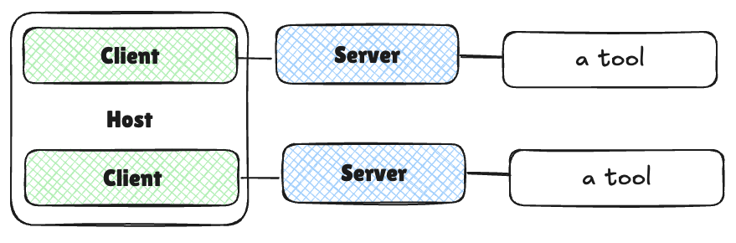
The MCP architecture consists of three primary components, each with well-defined roles and responsibilities: Host, Client, and Server. We touched on these in the previous section, but let’s dive deeper into each component and their responsibilities.
Host
The Host is the user-facing AI application that end-users interact with directly.
Examples include:
- AI Chat apps like OpenAI ChatGPT or Anthropic’s Claude Desktop
- AI-enhanced IDEs like Cursor, or integrations to tools like Continue.dev
- Custom AI agents and applications built in libraries like LangChain or smolagents
The Host’s responsibilities include:
- Managing user interactions and permissions
- Initiating connections to MCP Servers via MCP Clients
- Orchestrating the overall flow between user requests, LLM processing, and external tools
- Rendering results back to users in a coherent format
In most cases, users will select their host application based on their needs and preferences. For example, a developer may choose Cursor for its powerful code editing capabilities, while domain experts may use custom applications built in smolagents.
Client
The Client is a component within the Host application that manages communication with a specific MCP Server. Key characteristics include:
- Each Client maintains a 1:1 connection with a single Server
- Handles the protocol-level details of MCP communication
- Acts as the intermediary between the Host’s logic and the external Server
Server
The Server is an external program or service that exposes capabilities to AI models via the MCP protocol. Servers:
- Provide access to specific external tools, data sources, or services
- Act as lightweight wrappers around existing functionality
- Can run locally (on the same machine as the Host) or remotely (over a network)
- Expose their capabilities in a standardized format that Clients can discover and use
Communication Flow
Let’s examine how these components interact in a typical MCP workflow:
In the next section, we’ll dive deeper into the communication protocol that enables these components with practical examples.
- User Interaction: The user interacts with the Host application, expressing an intent or query.
- Host Processing: The Host processes the user’s input, potentially using an LLM to understand the request and determine which external capabilities might be needed.
- Client Connection: The Host directs its Client component to connect to the appropriate Server(s).
- Capability Discovery: The Client queries the Server to discover what capabilities (Tools, Resources, Prompts) it offers.
- Capability Invocation: Based on the user’s needs or the LLM’s determination, the Host instructs the Client to invoke specific capabilities from the Server.
- Server Execution: The Server executes the requested functionality and returns results to the Client.
- Result Integration: The Client relays these results back to the Host, which incorporates them into the context for the LLM or presents them directly to the user.
A key advantage of this architecture is its modularity. A single Host can connect to multiple Servers simultaneously via different Clients. New Servers can be added to the ecosystem without requiring changes to existing Hosts. Capabilities can be easily composed across different Servers.
As we discussed in the previous section, this modularity transforms the traditional M×N integration problem (M AI applications connecting to N tools/services) into a more manageable M+N problem, where each Host and Server needs to implement the MCP standard only once.
The architecture might appear simple, but its power lies in the standardization of the communication protocol and the clear separation of responsibilities between components. This design allows for a cohesive ecosystem where AI models can seamlessly connect with an ever-growing array of external tools and data sources.
Conclusion
These interaction patterns are guided by several key principles that shape the design and evolution of MCP. The protocol emphasizes standardization by providing a universal protocol for AI connectivity, while maintaining simplicity by keeping the core protocol straightforward yet enabling advanced features. Safety is prioritized by requiring explicit user approval for sensitive operations, and discoverability enables dynamic discovery of capabilities. The protocol is built with extensibility in mind, supporting evolution through versioning and capability negotiation, and ensures interoperability across different implementations and environments.
In the next section, we’ll explore the communication protocol that enables these components to work together effectively.
Understanding MCP Capabilities
MCP Servers expose a variety of capabilities to Clients through the communication protocol. These capabilities fall into four main categories, each with distinct characteristics and use cases. Let’s explore these core primitives that form the foundation of MCP’s functionality.
In this section, we’ll show examples as framework agnostic functions in each language. This is to focus on the concepts and how they work together, rather than the complexities of any framework.
In the coming units, we’ll show how these concepts are implemented in MCP specific code.
Tools
Tools are executable functions or actions that the AI model can invoke through the MCP protocol.
- Control: Tools are typically model-controlled, meaning that the AI model (LLM) decides when to call them based on the user’s request and context.
- Safety: Due to their ability to perform actions with side effects, tool execution can be dangerous. Therefore, they typically require explicit user approval.
- Use Cases: Sending messages, creating tickets, querying APIs, performing calculations.
Example: A weather tool that fetches current weather data for a given location:
Copied
def get_weather(location: str) -> dict:
"""Get the current weather for a specified location."""
# Connect to weather API and fetch data
return {
"temperature": 72,
"conditions": "Sunny",
"humidity": 45
}
Resources
Resources provide read-only access to data sources, allowing the AI model to retrieve context without executing complex logic.
- Control: Resources are application-controlled, meaning the Host application typically decides when to access them.
- Nature: They are designed for data retrieval with minimal computation, similar to GET endpoints in REST APIs.
- Safety: Since they are read-only, they typically present lower security risks than Tools.
- Use Cases: Accessing file contents, retrieving database records, reading configuration information.
Example: A resource that provides access to file contents:
Copied
def read_file(file_path: str) -> str:
"""Read the contents of a file at the specified path."""
with open(file_path, 'r') as f:
return f.read()
Prompts
Prompts are predefined templates or workflows that guide the interaction between the user, the AI model, and the Server’s capabilities.
- Control: Prompts are user-controlled, often presented as options in the Host application’s UI.
- Purpose: They structure interactions for optimal use of available Tools and Resources.
- Selection: Users typically select a prompt before the AI model begins processing, setting context for the interaction.
- Use Cases: Common workflows, specialized task templates, guided interactions.
Example: A prompt template for generating a code review:
Copied
def code_review(code: str, language: str) -> list:
"""Generate a code review for the provided code snippet."""
return [
{
"role": "system",
"content": f"You are a code reviewer examining {language} code. Provide a detailed review highlighting best practices, potential issues, and suggestions for improvement."
},
{
"role": "user",
"content": f"Please review this {language} code:\n\n```{language}\n{code}\n```"
}
]
Sampling
Sampling allows Servers to request the Client (specifically, the Host application) to perform LLM interactions.
- Control: Sampling is server-initiated but requires Client/Host facilitation.
- Purpose: It enables server-driven agentic behaviors and potentially recursive or multi-step interactions.
- Safety: Like Tools, sampling operations typically require user approval.
- Use Cases: Complex multi-step tasks, autonomous agent workflows, interactive processes.
Example: A Server might request the Client to analyze data it has processed:
Copied
def request_sampling(messages, system_prompt=None, include_context="none"):
"""Request LLM sampling from the client."""
# In a real implementation, this would send a request to the client
return {
"role": "assistant",
"content": "Analysis of the provided data..."
}
The sampling flow follows these steps:
- Server sends a sampling/createMessage request to the client
- Client reviews the request and can modify it
- Client samples from an LLM
- Client reviews the completion
- Client returns the result to the server
This human-in-the-loop design ensures users maintain control over what the LLM sees and generates. When implementing sampling, it’s important to provide clear, well-structured prompts and include relevant context.
How Capabilities Work Together
Let’s look at how these capabilities work together to enable complex interactions. In the table below, we’ve outlined the capabilities, who controls them, the direction of control, and some other details.
Capability | Controlled By | Direction | Side Effects | Approval Needed | Typical Use Cases
Tools | Model (LLM) | Client → Server | Yes (potentially) | Yes | Actions, API calls, data manipulation
Resources | Application | Client → Server | No (read-only) | Typically no | Data retrieval, context gathering
Prompts | User | Server → Client | No | No (selected by user) | Guided workflows, specialized templates
Sampling | Server | Server → Client → Server | Indirectly | Yes | Multi-step tasks, agentic behaviors
These capabilities are designed to work together in complementary ways:
- A user might select a Prompt to start a specialized workflow
- The Prompt might include context from Resources
- During processing, the AI model might call Tools to perform specific actions
- For complex operations, the Server might use Sampling to request additional LLM processing
The distinction between these primitives provides a clear structure for MCP interactions, enabling AI models to access information, perform actions, and engage in complex workflows while maintaining appropriate control boundaries.
Discovery Process
One of MCP’s key features is dynamic capability discovery. When a Client connects to a Server, it can query the available Tools, Resources, and Prompts through specific list methods:
- tools/list: Discover available Tools
- resources/list: Discover available Resources
- prompts/list: Discover available Prompts
This dynamic discovery mechanism allows Clients to adapt to the specific capabilities each Server offers without requiring hardcoded knowledge of the Server’s functionality.
Conclusion
Understanding these core primitives is essential for working with MCP effectively. By providing distinct types of capabilities with clear control boundaries, MCP enables powerful interactions between AI models and external systems while maintaining appropriate safety and control mechanisms.
In the next section, we’ll explore how Gradio integrates with MCP to provide easy-to-use interfaces for these capabilities.
MCP SDK
The Model Context Protocol provides official SDKs for both JavaScript, Python and other languages. This makes it easy to implement MCP clients and servers in your applications. These SDKs handle the low-level protocol details, allowing you to focus on building your application’s capabilities.
SDK Overview
Both SDKs provide similar core functionality, following the MCP protocol specification we discussed earlier. They handle:
- Protocol-level communication
- Capability registration and discovery
- Message serialization/deserialization
- Connection management
- Error handling
Core Primitives Implementation
Let’s explore how to implement each of the core primitives (Tools, Resources, and Prompts) using both SDKs.
Copied
from mcp.server.fastmcp import FastMCP

# Create an MCP server
mcp = FastMCP("Weather Service")

# Tool implementation

def get_weather(location: str) -> str:
"""Get the current weather for a specified location."""
return f"Weather in {location}: Sunny, 72°F"

# Resource implementation

def weather_resource(location: str) -> str:
"""Provide weather data as a resource."""
return f"Weather data for {location}: Sunny, 72°F"

# Prompt implementation

def weather_report(location: str) -> str:
"""Create a weather report prompt."""
return f"""You are a weather reporter. Weather report for {location}?"""

# Run the server
if __name__ == "__main__":
mcp.run()
Once you have your server implemented, you can start it by running the server script.
Copied
mcp dev server.py
This will initialize a development server running the file server.py. And log the following output:
Copied
Starting MCP inspector...
⚙️ Proxy server listening on port 6277
Spawned stdio transport
Connected MCP client to backing server transport
Created web app transport
Set up MCP proxy
🔍 MCP Inspector is up and running at http://127.0.0.1:6274 🚀
You can then open the MCP Inspector at http://127.0.0.1:6274 to see the server’s capabilities and interact with them.
You’ll see the server’s capabilities and the ability to call them via the UI.
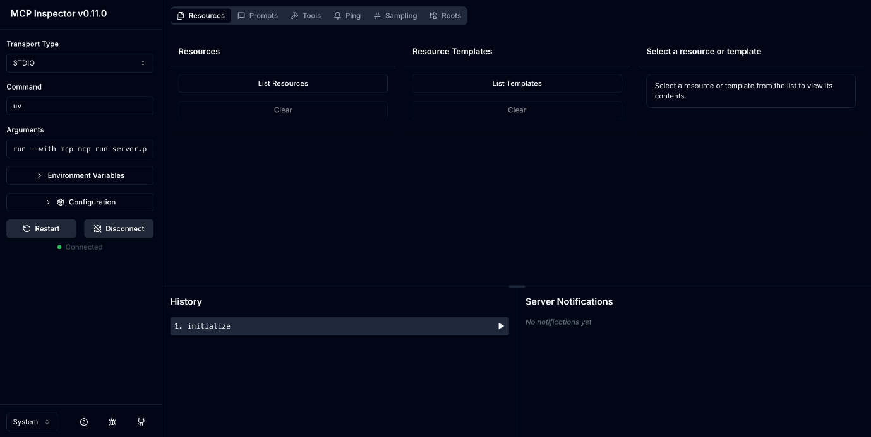
MCP SDKs
MCP is designed to be language-agnostic, and there are official SDKs available for several popular programming languages:
Language | Repository | Maintainer(s) | Status
TypeScript | github.com/modelcontextprotocol/typescript-sdk | Anthropic | Active
Python | github.com/modelcontextprotocol/python-sdk | Anthropic | Active
Java | github.com/modelcontextprotocol/java-sdk | Spring AI (VMware) | Active
Kotlin | github.com/modelcontextprotocol/kotlin-sdk | JetBrains | Active
C# | github.com/modelcontextprotocol/csharp-sdk | Microsoft | Active (Preview)
Swift | github.com/modelcontextprotocol/swift-sdk | loopwork-ai | Active
Rust | github.com/modelcontextprotocol/rust-sdk | Anthropic/Community | Active
Dart | https://github.com/leehack/mcp_dart | Flutter Community | Active
These SDKs provide language-specific abstractions that simplify working with the MCP protocol, allowing you to focus on implementing the core logic of your servers or clients rather than dealing with low-level protocol details.
Next Steps
We’ve only scratched the surface of what you can do with the MCP but you’ve already got a basic server running. In fact, you’ve also connected to it using the MCP Client in the browser.
In the next section, we’ll look at how to connect to your server from an LLM.
MCP Clients
Now that we have a basic understanding of the Model Context Protocol, we can explore the essential role of MCP Clients in the Model Context Protocol ecosystem.
In this part of Unit 1, we’ll explore the essential role of MCP Clients in the Model Context Protocol ecosystem.
In this section, you will:
- Understand what MCP Clients are and their role in the MCP architecture
- Learn about the key responsibilities of MCP Clients
- Explore the major MCP Client implementations
- Discover how to connect to the Hugging Face MCP Server and built-in tools
- See practical examples of MCP Client usage
In this page we’re going to show examples of how to set up MCP Clients in a few different ways using the JSON notation. For now, we will use examples like path/to/server.py to represent the path to the MCP Server. In the next unit, we’ll implement this with real MCP Servers.
For now, focus on understanding the MCP Client notation. We’ll implement the MCP Servers in the next unit.
Understanding MCP Clients
MCP Clients are crucial components that act as the bridge between AI applications (Hosts) and external capabilities provided by MCP Servers. Think of the Host as your main application (like an AI assistant or IDE) and the Client as a specialized module within that Host responsible for handling MCP communications.
User Interface Client
Let’s start by exploring the user interface clients that are available for the MCP.
Chat Interface Clients
- Claude Desktop (Anthropic)
Interactive Development Clients
- VS Code extensions with MCP (e.g., Continue)
- Cursor IDE (built-in MCP client)
- Zed editor
These clients support connecting to multiple MCP servers and real-time tool invocation.
Quick connect to Hugging Face MCP Server
Hugging Face provides a hosted MCP server with built-in tools for exploring models, datasets, Spaces, and papers.
- Visit https://huggingface.co/settings/mcp while logged in.
- Select your MCP-compatible client (e.g., VS Code, Cursor, Zed, Claude Desktop).
- Copy the generated configuration snippet into your client’s MCP config.
- Restart or reload your client. You should see “Hugging Face” connected.
Tip: Prefer the generated snippet over hand-written config; it’s tailored per client.
Configuring MCP Clients
Now that we’ve covered the core of the MCP protocol, let’s look at how to configure your MCP servers and clients.
Effective deployment of MCP servers and clients requires proper configuration.
The MCP specification is still evolving, so the configuration methods are subject to evolution. We’ll focus on the current best practices for configuration.
MCP Configuration Files
MCP hosts use configuration files to manage server connections. These files define which servers are available and how to connect to them.
Fortunately, the configuration files are very simple, easy to understand, and consistent across major MCP hosts.
mcp.json Structure
The standard configuration file for MCP is named mcp.json. Here’s the basic structure:
This is the basic structure of the mcp.json can be passed to applications like Claude Desktop, Cursor, or VS Code.
Copied
{
"servers": [
{
"name": "Server Name",
"transport": {
"type": "stdio|sse",
// Transport-specific configuration
}
}
]
}
In this example, we have a single server with a name and a transport type. The transport type is either stdio or sse.
Configuration for stdio Transport
For local servers using stdio transport, the configuration includes the command and arguments to launch the server process:
Copied
{
"servers": [
{
"name": "File Explorer",
"transport": {
"type": "stdio",
"command": "python",
"args": ["/path/to/file_explorer_server.py"] // This is an example, we'll use a real server in the next unit
}
}
]
}
Here, we have a server called “File Explorer” that is a local script.
Configuration for HTTP+SSE Transport
For remote servers using HTTP+SSE transport, the configuration includes the server URL:
Copied
{
"servers": [
{
"name": "Remote API Server",
"transport": {
"type": "sse",
"url": "https://example.com/mcp-server"
}
}
]
}
Environment Variables in Configuration
Environment variables can be passed to server processes using the env field. Here’s how to access them in your server code:
In Python, we use the os module to access environment variables:
Copied
import os

# Access environment variables
github_token = os.environ.get("GITHUB_TOKEN")
if not github_token:
raise ValueError("GITHUB_TOKEN environment variable is required")

# Use the token in your server code
def make_github_request():
headers = {"Authorization": f"Bearer {github_token}"}
# ... rest of your code
The corresponding configuration in mcp.json would look like this:
Copied
{
"servers": [
{
"name": "GitHub API",
"transport": {
"type": "stdio",
"command": "python",
"args": ["/path/to/github_server.py"], // This is an example, we'll use a real server in the next unit
"env": {
"GITHUB_TOKEN": "your_github_token"
}
}
}
]
}
Configuration Examples
Let’s look at some real-world configuration scenarios:
Scenario 1: Local Server Configuration
In this scenario, we have a local server that is a Python script which could be a file explorer or a code editor.
Copied
{
"servers": [
{
"name": "File Explorer",
"transport": {
"type": "stdio",
"command": "python",
"args": ["/path/to/file_explorer_server.py"] // This is an example, we'll use a real server in the next unit
}
}
]
}
Scenario 2: Remote Server Configuration
In this scenario, we have a remote server that is a weather API.
Copied
{
"servers": [
{
"name": "Weather API",
"transport": {
"type": "sse",
"url": "https://example.com/mcp-server" // This is an example, we'll use a real server in the next unit
}
}
]
}
Proper configuration is essential for successfully deploying MCP integrations. By understanding these aspects, you can create robust and reliable connections between AI applications and external capabilities.
In the next section, we’ll explore the ecosystem of MCP servers available on Hugging Face Hub and how to publish your own servers there.
Tiny Agents Clients
Now, let’s explore how to use MCP Clients within code.
You can also use tiny agents as MCP Clients to connect directly to MCP servers from your code. Tiny agents provide a simple way to create AI agents that can use tools from MCP servers.
Tiny Agent can run MCP servers with a command line environment. To do this, we will need to install npm and run the server with npx. We’ll need these for both Python and JavaScript.
Let’s install npx with npm. If you don’t have npm installed, check out the npm documentation.
Setup
First, we will need to install npx if you don’t have it installed. You can do this with the following command:
Copied
# install npx
npm install -g npx
Then, we will need to install the huggingface_hub package with the MCP support. This will allow us to run MCP servers and clients.
Copied
pip install "huggingface_hub[mcp]>=0.32.0"
Then, we will need to log in to the Hugging Face Hub to access the MCP servers. You can do this with the huggingface-cli command line tool. You will need a login token to do this.
Copied
huggingface-cli login
Configure Access Token Permissions
After creating your Hugging Face access token and logging in, you need to ensure your token has the proper permissions to work with inference providers.
Important: If you skip this step, you may encounter authentication errors when running tiny agents with hosted models.
- Go to your Hugging Face Access Tokens page
- Find your MCP token and click the three dots (⋮) next to it
- Select “Edit permissions”
- Under the Inference section, check the box for:
  - “Make calls to Inference Providers”
- Save your changes
This permission is required because tiny agents need to make API calls to hosted models like Qwen/Qwen2.5-72B-Instruct through providers like Nebius.
Connecting to MCP Servers
Now, let’s create an agent configuration file agent.json.
Copied
{
"name": "playwright-agent",
"description": "Agent with Playwright MCP server",
"model": "Qwen/Qwen2.5-72B-Instruct",
"provider": "nebius",
"servers": [
{
"type": "stdio",
"command": "npx",
"args": ["@playwright/mcp@latest"]
}
]
}
In this configuration, we are using the @playwright/mcp MCP server. This is an MCP server that can control a browser with Playwright.
Now you can run the agent:
Copied
tiny-agents run agent.json
In the video below, we run the agent and ask it to open a new tab in the browser.
The following example shows a web-browsing agent configured to use the Qwen/Qwen2.5-72B-Instruct model via Nebius inference provider, and it comes equipped with a playwright MCP server, which lets it use a web browser! The agent config is loaded specifying its path in the tiny-agents/tiny-agents Hugging Face dataset.
When you run the agent, you’ll see it load, listing the tools it has discovered from its connected MCP servers. Then, it’s ready for your prompts!
Prompt used in this demo:
do a Web Search for HF inference providers on Brave Search and open the first result and then give me the list of the inference providers supported on Hugging Face
Next Steps
Now that you understand MCP Clients, you’re ready to:
- Explore specific MCP Server implementations
- Learn about creating custom MCP Clients
- Dive into advanced MCP integration patterns
Let’s continue our journey into the world of Model Context Protocol!
Hugging Face MCP Server
The Hugging Face MCP (Model Context Protocol) Server connects your MCP-compatible AI assistant (for example VS Code, Cursor, Zed, or Claude Desktop) directly to the Hugging Face Hub. Once connected, your assistant can search and explore Hub resources and use community tools, all from within your editor, chat or CLI.
The main advanatage of the Hugging Face MCP Server is that it provides a built-in tools for the hub as well as community tools based on Gradio Spaces. As we start to build our own MCP servers, we’ll see that we can use the Hugging Face MCP Server as a reference for our own MCP servers.
What you can do
- Search and explore Hub resources: models, datasets, Spaces, and papers.
- Run community tools via MCP-compatible Gradio apps hosted on Spaces.
- Bring results back into your assistant with metadata, links, and context.
Built-in tools
The server provides curated tools that work across supported clients:
- Models search and exploration (filter by task, library, downloads, likes)
- Datasets search and exploration (filter by tags, size, modality)
- Spaces semantic search (find apps by capability, e.g., TTS, ASR, OCR)
- Papers semantic search (discover relevant research on the Hub)
Get started
- Open your MCP settings: visit https://huggingface.co/settings/mcp while logged in.
- Pick your client: select your MCP-compatible client (for example VS Code, Cursor, Zed, Claude Desktop). The page shows client-specific instructions and a ready-to-copy configuration snippet.
- Paste and restart: copy the snippet into your client’s MCP configuration, save, and restart/reload the client. You should see “Hugging Face” (or similar) listed as a connected MCP server in your client.
The settings page generates the exact configuration your client expects. Use it rather than writing config by hand.
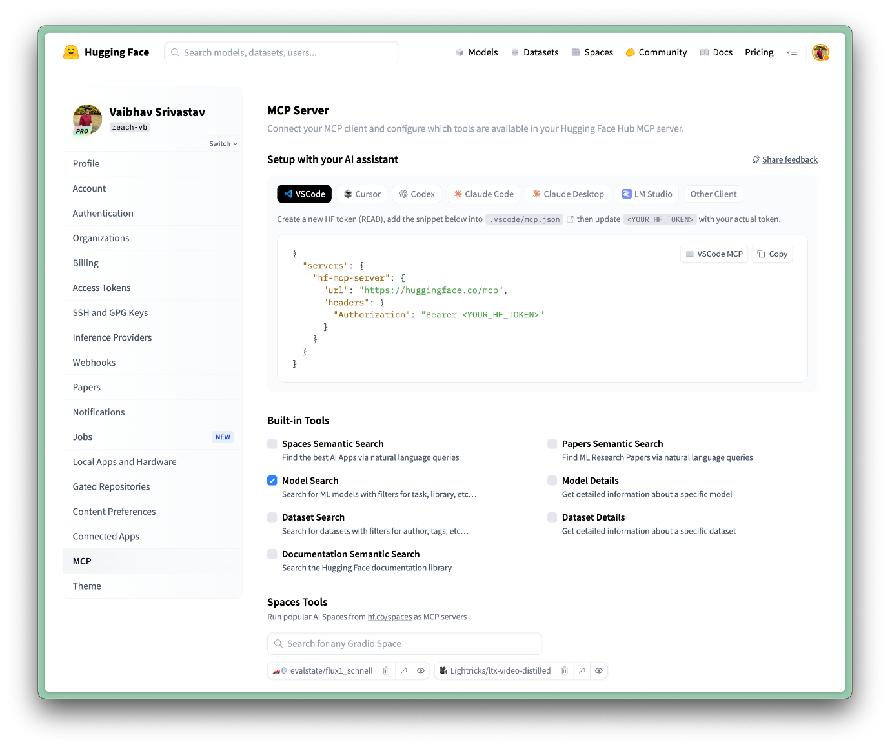
Using the server
After connecting, ask your assistant to use the Hugging Face tools. Example prompts:
- “Search Hugging Face models for Qwen 3 quantizations.”
- “Find a Space that can transcribe audio files.”
- “Show datasets about weather time-series.”
- “Create a 1024 × 1024 image of a cat in Ghibli style.”
Your assistant will call MCP tools exposed by the Hugging Face MCP Server (including Spaces) and return results (titles, owners, downloads, links, and so on). You can then open the resource on the Hub or continue iterating in the same chat.
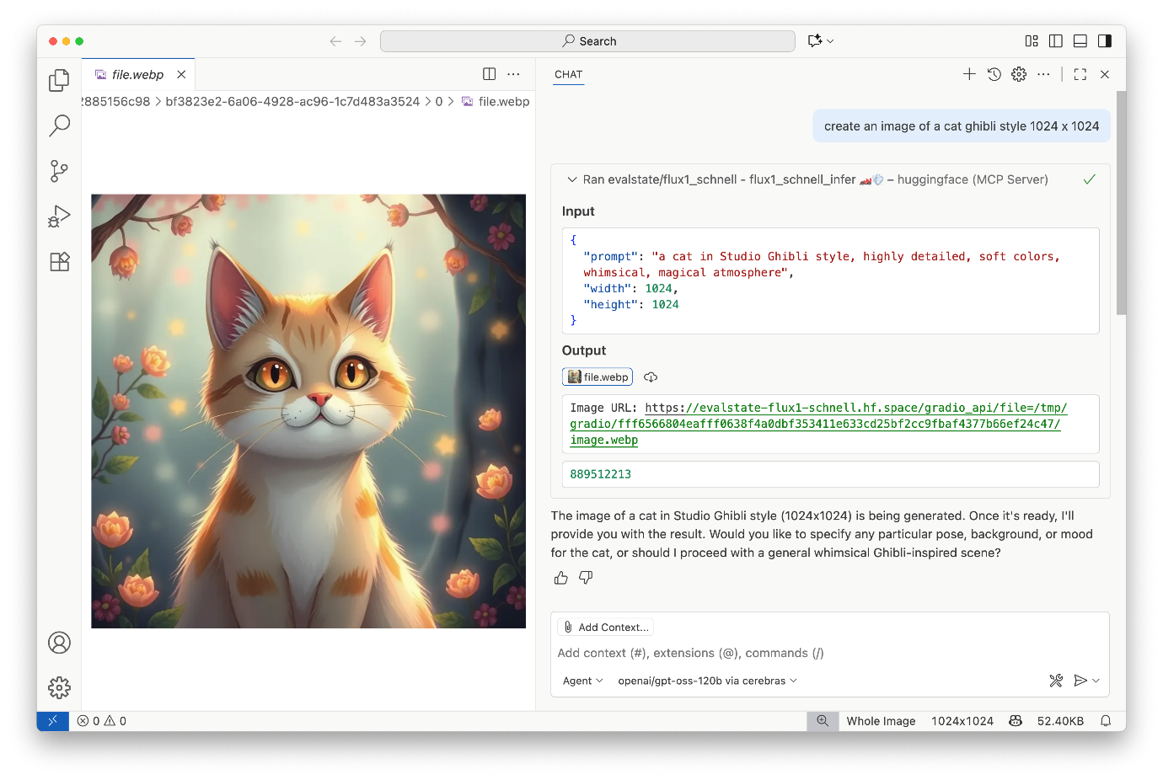
Add community tools (Spaces)
You can extend your setup with MCP-compatible Gradio Spaces built by the community:
- Explore Spaces with MCP support here.
- Add the relevant space in your MCP settings on Hugging Face here.
Gradio MCP apps expose their functions as tools (with arguments and descriptions) so your assistant can call them directly. Please, restart or refresh your client so it picks up new tools you add.
Learn more
- Settings and client setup: https://huggingface.co/settings/mcp
- Changelog announcement: https://huggingface.co/changelog/hf-mcp-server
- HF MCP Server documentation: https://huggingface.co/docs/hub/en/hf-mcp-server
- Building your own MCP server with Gradio and Hub tools: https://huggingface.co/docs/hub/main/agents
<>Update on GitHub
Gradio MCP Integration
We’ve now explored the core concepts of the MCP protocol and how to implement MCP Servers and Clients. In this section, we’re going to make things slightly easier by using Gradio to create an MCP Server!
Gradio is a popular Python library for quickly creating customizable web interfaces for machine learning models.
Introduction to Gradio
Gradio allows developers to create UIs for their models with just a few lines of Python code. It’s particularly useful for:
- Creating demos and prototypes
- Sharing models with non-technical users
- Testing and debugging model behavior
With the addition of MCP support, Gradio now offers a straightforward way to expose AI model capabilities through the standardized MCP protocol.
Combining Gradio with MCP allows you to create both human-friendly interfaces and AI-accessible tools with minimal code. But best of all, Gradio is already well-used by the AI community, so you can use it to share your MCP Servers with others.
Prerequisites
To use Gradio with MCP support, you’ll need to install Gradio with the MCP extra:
Copied
uv pip install "gradio[mcp]"
You’ll also need an LLM application that supports tool calling using the MCP protocol, such as Cursor ( known as “MCP Hosts”).
Creating an MCP Server with Gradio
Let’s walk through a basic example of creating an MCP Server using Gradio:
Copied
import gradio as gr

def letter_counter(word: str, letter: str) -> int:
"""
Count the number of occurrences of a letter in a word or text.

Args:
word (str): The input text to search through
letter (str): The letter to search for

Returns:
int: The number of times the letter appears in the text
"""
word = word.lower()
letter = letter.lower()
count = word.count(letter)
return count

# Create a standard Gradio interface
demo = gr.Interface(
fn=letter_counter,
inputs=["textbox", "textbox"],
outputs="number",
title="Letter Counter",
description="Enter text and a letter to count how many times the letter appears in the text."
)

# Launch both the Gradio web interface and the MCP server
if __name__ == "__main__":
demo.launch(mcp_server=True)
With this setup, your letter counter function is now accessible through:
- A traditional Gradio web interface for direct human interaction
- An MCP Server that can be connected to compatible clients
The MCP server will be accessible at:
Copied
http://your-server:port/gradio_api/mcp/sse
The application itself will still be accessible and it looks like this:
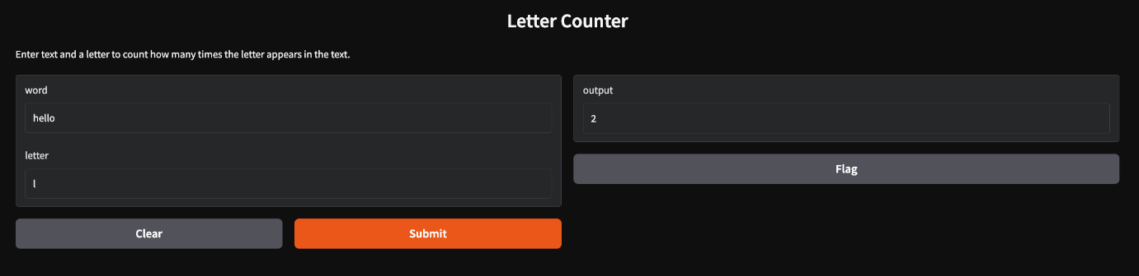
How It Works Behind the Scenes
When you set mcp_server=True in launch(), several things happen:
- Gradio functions are automatically converted to MCP Tools
- Input components map to tool argument schemas
- Output components determine the response format
- The Gradio server now also listens for MCP protocol messages
- JSON-RPC over HTTP+SSE is set up for client-server communication
Key Features of the Gradio <> MCP Integration
- Tool Conversion: Each API endpoint in your Gradio app is automatically converted into an MCP tool with a corresponding name, description, and input schema. To view the tools and schemas, visit http://your-server:port/gradio_api/mcp/schema or go to the “View API” link in the footer of your Gradio app, and then click on “MCP”.
- Environment Variable Support: There are two ways to enable the MCP server functionality:
- Using the mcp_server parameter in launch():
Copied
demo.launch(mcp_server=True)
- Using environment variables:
Copied
export GRADIO_MCP_SERVER=True
- File Handling: The server automatically handles file data conversions, including:
  - Converting base64-encoded strings to file data
  - Processing image files and returning them in the correct format
  - Managing temporary file storage
It is strongly recommended that input images and files be passed as full URLs (“http://…” or “https://…”) as MCP Clients do not always handle local files correctly.
- Hosted MCP Servers on 🤗 Spaces: You can publish your Gradio application for free on Hugging Face Spaces, which will allow you to have a free hosted MCP server. Here’s an example of such a Space: https://huggingface.co/spaces/abidlabs/mcp-tools
Use MCP-compatible Spaces from your client
You can connect any MCP-compatible Space to your assistant via Hugging Face MCP settings:
- Explore MCP-compatible Spaces: https://huggingface.co/spaces?search=mcp
- Open https://huggingface.co/settings/mcp (logged in) and add the Space.
- Restart or refresh your MCP client so it discovers the new tools.
These Spaces expose their functions as tools with arguments and descriptions, so your assistant can call them directly.
Troubleshooting Tips
- Type Hints and Docstrings: Ensure you provide type hints and valid docstrings for your functions. The docstring should include an “Args:” block with indented parameter names.
- String Inputs: When in doubt, accept input arguments as str and convert them to the desired type inside the function.
- SSE Support: Some MCP Hosts don’t support SSE-based MCP Servers. In those cases, you can use mcp-remote:
Copied
{
"mcpServers": {
"gradio": {
"command": "npx",
"args": [
"mcp-remote",
"http://your-server:port/gradio_api/mcp/sse"
]
}
}
}
- Restart: If you encounter connection issues, try restarting both your MCP Client and MCP Server.
Share your MCP Server
You can share your MCP Server by publishing your Gradio app to Hugging Face Spaces. The video below shows how to create a Hugging Face Space.
Now, you can share your MCP Server with others by sharing your Hugging Face Space.
Conclusion
Gradio’s integration with MCP provides an accessible entry point to the MCP ecosystem. By leveraging Gradio’s simplicity and adding MCP’s standardization, developers can quickly create both human-friendly interfaces and AI-accessible tools with minimal code.
As we progress through this course, we’ll explore more sophisticated MCP implementations, but Gradio offers an excellent starting point for understanding and experimenting with the protocol.
In the next unit, we’ll dive deeper into building MCP applications, focusing on setting up development environments, exploring SDKs, and implementing more advanced MCP Servers and Clients.
<>Update on GitHub
Unit1 recap
Model Context Protocol (MCP)
The MCP is a standardized protocol designed to connect AI models with external tools, data sources, and environments. It addresses the limitations of existing AI systems by enabling interoperability and access to real-time information.
Key Concepts
Client-Server Architecture
MCP follows a client-server model where clients manage communication between users and servers. This architecture promotes modularity, allowing for easy addition of new servers without requiring changes to existing hosts.
Components
Host
The user-facing AI application that serves as the interface for end-users.
Client
A component within the host application responsible for managing communication with a specific MCP server. Clients maintain 1:1 connections with servers and handle protocol-level details.
Server
An external program or service that provides access to tools, data sources, or services via the MCP protocol. Servers act as lightweight wrappers around existing functionalities.
Capabilities
Tools
Executable functions that can perform actions (e.g., sending messages, querying APIs). Tools are typically model-controlled and require user approval due to their ability to perform actions with side effects.
Resources
Read-only data sources for context retrieval without significant computation. Resources are application-controlled and designed for data retrieval similar to GET endpoints in REST APIs.
Prompts
Pre-defined templates or workflows that guide interactions between users, AI models, and available capabilities. Prompts are user-controlled and set the context for interactions.
Sampling
Server-initiated requests for LLM processing, enabling server-driven agentic behaviors and potentially recursive or multi-step interactions. Sampling operations typically require user approval.
Communication Protocol
The MCP protocol uses JSON-RPC 2.0 as the message format for communication between clients and servers. Two primary transport mechanisms are supported: stdio (for local communication) and HTTP+SSE (for remote communication). Messages include requests, responses, and notifications.
Discovery Process
MCP allows clients to dynamically discover available tools, resources, and prompts through list methods (e.g., tools/list). This dynamic discovery mechanism enables clients to adapt to the specific capabilities each server offers without requiring hardcoded knowledge of server functionality.
MCP SDKs
Official SDKs are available in various programming languages for implementing MCP clients and servers. These SDKs handle protocol-level communication, capability registration, and error handling, simplifying the development process.
Gradio Integration
Gradio allows easy creation of web interfaces that expose capabilities to the MCP protocol, making it accessible for both humans and AI models. This integration provides a human-friendly interface alongside AI-accessible tools with minimal code.
Hugging Face MCP enhancements
- Hosted MCP Server now integrates with more clients (VS Code, Cursor, Zed, Claude Desktop).
- Curated built-in tools for searching models, datasets, Spaces, and papers.
- One-click configuration snippets from https://huggingface.co/settings/mcp.
- Add MCP-compatible Gradio Spaces via settings and use them directly from your assistant.
<>Update on GitHub

